**Phase 9: Reporting, Dashboards & Security Review**

Building reports

Building custom reports and linking the relationship with other objects

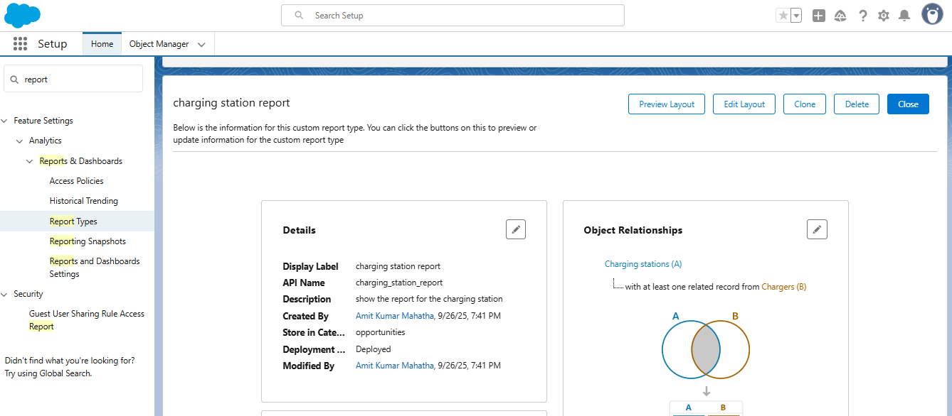

Navigation guide

1.setup

2.report types

3.build custom reports

4.select the custom object you want to create reports

5.create the report